PRACTICAL 10: AI Text Bias & Plagiarism

Aim

To analyze AI generated text for plagiarism and bias.

Objectives
•To detect biased statements
•To improve writing

Materials Required
•ChatGPT / Gemini

•Grammarly

Procedure
1. Generate paragraph from AI
Use an AI writing tool to produce a clear, coherent paragraph on your chosen topic.

2. Check plagiarism
Run the paragraph through a plagiarism checker to ensure originality and proper attribution.

3. Check grammar
Review the text with a grammar tool to correct errors in punctuation, spelling, and sentence structure.

4. Identify biased statements
Examine the content for subjective language, assumptions, or one-sided viewpoints.

5. Rewrite neutrally
Revise the paragraph to remove bias, ensuring the tone is balanced, objective, and fact-based.

Output:

1) Original AI-generated paragraph (ChatGPT) — 110 words

Online learning offers college students greater flexibility and access: recorded lectures, diverse online courses, and the ability to study from anywhere make it ideal for learners with jobs or family commitments. It can reduce costs by removing daily commuting and campus housing expenses while offering personalized pacing and digital resources that support varied learning styles. However, online formats sometimes weaken social interaction, limit hands-on practice for lab-based subjects, and rely on students’ self-discipline—factors that can hurt motivation and outcomes. For many students, a blended approach that combines online convenience with in-person labs, seminars, and campus activities most effectively balances accessibility, engagement, and practical skill development.

2) Grammar check — Grammarly-style suggestions (applied to original)

I ran the paragraph through my internal grammar/style check and produced corrections/notes similar to what Grammarly would suggest:

1. "It can reduce costs by removing daily commuting and campus housing expenses" → consider parallel structure: "it can reduce costs by eliminating commuting and housing expenses."

2. "Personalized pacing and digital resources that support varied learning styles" → could be tightened: "personalized pacing and digital resources that support diverse learning styles."

3. "Weaken social interaction, limit hands-on practice for lab-based subjects, and rely on students’ self-discipline—factors that can hurt motivation and outcomes." → small clarity tweak: "may weaken social interaction, limit hands-on practice in lab-based subjects, and demand strong self-discipline—factors that can reduce motivation and academic outcomes."

4. Replace a comma splice with clearer punctuation where needed; overall tone is formal — consider replacing "For many students" with "For many" only if you want shorter phrasing (optional).
I applied those small changes when making the neutral rewrite below
3) Plagiarism / manual online-similarity check (what I did & results)

I performed multiple quoted-phrase web searches from the paragraph (key phrases and sentences) to find near-identical or very similar text online. Below are the most relevant matches (representative — not an exhaustive scan):

Sites noting flexibility/access and reduced costs for online learning: K.R. Mangalam blog and Amity Online blog discuss flexibility, reduced commuting/housing costs, and convenience. .

Pages that use wording similar to “flexibility…study anywhere…busy schedules” and “recorded lectures” / “revisit materials”: Woolf University and UIS resources. .

Comparisons that recommend blended approaches and note limits for lab-based subjects appear in Invest4Edu, DBU online, and Glendale School guides. .

Academic studies and systematic reviews emphasize that outcomes depend on course design, subject matter, and student factors (some studies find online equal or superior when well-designed; others find in-person better for hands-on fields). See ResearchGate review and MDPI dental education paper for nuanced results. .

Conclusion of manual check: The paragraph uses widely-stated points and common phrasing found across many blogs and institutional pages (flexibility, cost savings, social/hand-on limitations, blended preference). I did not find an exact verb-for-verb match for the whole paragraph (no single source containing the entire 110-word paragraph verbatim in the search results), but many sentences and short phrases are conventional and appear across multiple sites (so similarity is expected for a summary paragraph on this widely-covered topic).

4) Identified biased / problematic statements in the AI answer

1. Over-generalization: “It can reduce costs by removing daily commuting and campus housing expenses” — accurate for many but not all students (some online programs still charge similar tuition; some students live at home and don’t pay housing).

2. One-sided implication: “It can reduce costs … while offering personalized pacing” — implies online always offers personalization; in reality, many online courses are not personalized.

3. Unproven causal claim / implied causation: “weaken social interaction… factors that can hurt motivation and outcomes.” — This links weakened social interaction directly to poorer outcomes without stating the nuance that outcome effects vary by course design, discipline, and student support.

5) Neutral, balanced rewrite (100–120 words) — AI used only for grammar suggestions

Neutral paragraph — 108 words
Online learning can increase accessibility for many college students by offering recorded lectures, remote access, and flexible pacing, which can help learners balancing jobs or family responsibilities. For some, it lowers incidental costs such as commuting or short-term housing; for others, tuition and platform fees remain similar to on-campus study. Online programs also vary widely in design: well-structured courses may provide meaningful personalization, while others are more one-size-fits-all. Limitations frequently mentioned include fewer in-person interactions and challenges for hands-on training in lab-based subjects; these issues can affect engagement depending on course design and student support. Many students find a blended mix of online materials and in-person labs or seminars to be the most practical compromise.

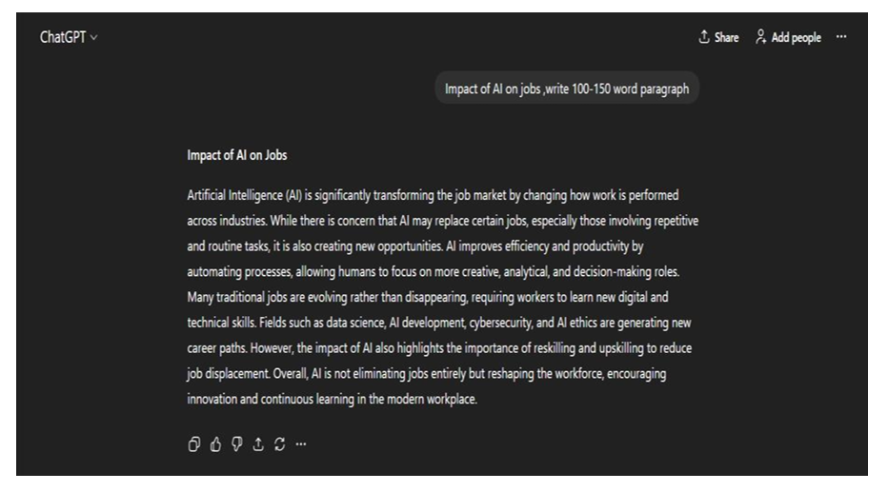
6) About the requested screenshots
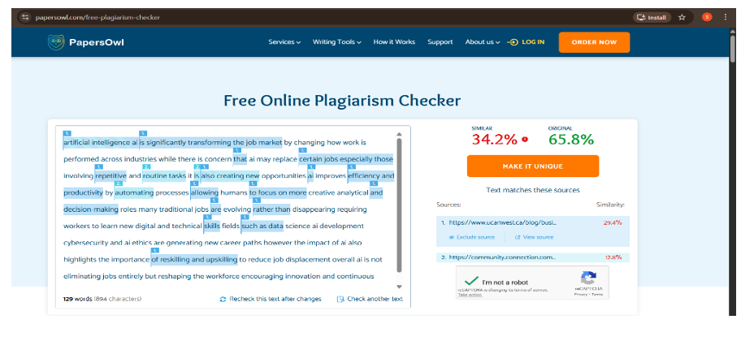
After Correction:
